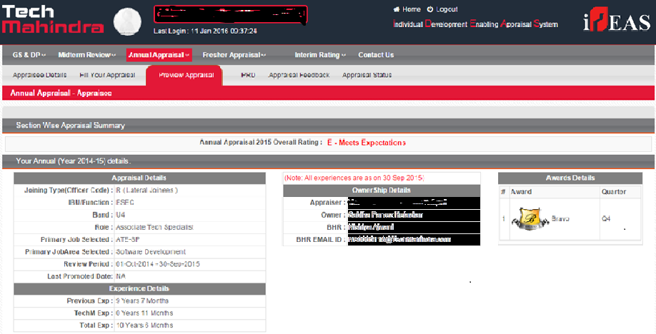

**Note: TechM logo, Associate Name, Appraiser Name, Period of Review (latest cycle) details should be mandatory. Only first page is sufficient.**